East Sussex Pension Fund IHLI Policy
Further information for employers
March 2021

IHLI Team
For and on behalf of Hymans Robertson LLP

Contents

East Sussex Pension Fund IHLI Policy Page

1 Introduction 1
2 Ill health early retirement strain costs 1
3 What is Ill Health Liability Insurance? 1
4 IHLI claims process 2
5 Employee Assistance Programme 5
6 Care Concierge 6
7 FAQs 7
8 Employers who previously had individual employer held policies 8
9 Hymans’ IHLI team contact details 9

- Introduction
You have received this document because you are one of the employers within East Sussex Pension Fund (the “Fund”) who will be covered by the Ill Health Liability Insurance (“IHLI”) policy set up by the Administering Authority to the Fund, East Sussex County Council. This policy to protect employers will come into force with effect from 1st April 2021. The policy, which is funded within the contributions set for the financial years 2021/22 to 2022/23, covers all small and medium employers with less than 200 active members, employers considered to pose a higher risk to the Fund and those larger employers who opted in to the cover. This document is intended to set out the key information and processes for employers relating to the operation of the insurance policy.
- Ill health early retirement strain costs
The LGPS provides many valuable benefits for your employees including retirement benefits that apply in the event of ill health early retirement (“IHER”). When one of your employees can no longer work and retires due to ill health, there is an increase in the pension liability (“the strain cost”) for you as the employer. This results from:
- Early payment of the accrued pension; and
- An increase in the benefits payable to the member based on either full prospective service to normal retirement age for a tier 1 IHER or 25% of prospective service for a tier 2 IHER.
The table below illustrates some recent costs in the Fund. The figures shown represent an immediate increase to the liabilities (and hence deficit) of the employers.
Employer | Member Age | Salary | Strain
Academy | 34 | £20,000 | £155,000
Contractor | 49 | £19,000 | £163,000
Council | 45 | £39,000 | £534,000

- What is Ill Health Liability Insurance?
IHLI was developed by Legal & General (L&G) at the request of LGPS funds to help them and their employers manage the risk of the strain costs from unexpected IHERs. In the event of a tier 1 or tier 2 IHER of one of your employees, the insurance policy will, on provision of the required claim forms to the insurer, pay the amount of the Fund calculated strain cost. The insurer will pay this money directly to the Fund where it will be added to your assets to cover the cost. This new system will protect all employers covered from facing large ill health strain costs in the future.
Any queries should be directed to our IHLI team in the first instance. We can be reached at:
Email: IHLI@hymans.co.uk
Telephone: 0121 210 4356
Address: IHLI Team, Hymans Robertson LLP, 45 Church Street, Birmingham, B3 2RT.
- IHLI claims process
A copy of the IHLI Claim Form was included in the email issued to employers along with this ‘Further information for employers’ document. All employers in the insured group covered by East Sussex Pension Fund’s blanket insurance policy should familiarise themselves with the claim process and employer requirements as set out in full below. Failure to adhere to this process may result in significant pension strain costs being charged to you as an employer.

  - Establishing eligibility of a claim
The first step in the claim process is to establish if a pending IHER is an eligible claim. The insurance does not cover any active members who were already in the IHER medical assessment phase at 1st April 2021 unless the retirement is from an employer who previously held their own individual IHLI policy. Employers are encouraged to notify the Administering Authority of any such cases shortly after 1st April 2021 as, in the event that one of these cases results in a claim, the Administering Authority and/or Hymans’ IHLI team may seek clarity from the employer as to the date when the IHER process started. Legal & General’s definition of this date is detailed under 4.5, 6.
  - Submitting a claim
Whilst the IHER process is ongoing, employers are advised to retain copies of any relevant medical information (occupational health reports, etc) used in the retirement process and the occupational health certificate confirming eligibility for tier 1 or tier 2 ill health early retirement benefit and. These may be required for some claims – see 4.3.
Once an eligible IHER has been finalised, the Administering Authority will check the calculated strain cost (i.e. amount to be claimed).

If the claim is £500,000 or less:
The Administering Authority will complete the claim forms and submit claims on the employers’ behalf. The Administering Authority will require input from the employer to complete Part A, section 2 of the IHLI claim form (see screenshot below).
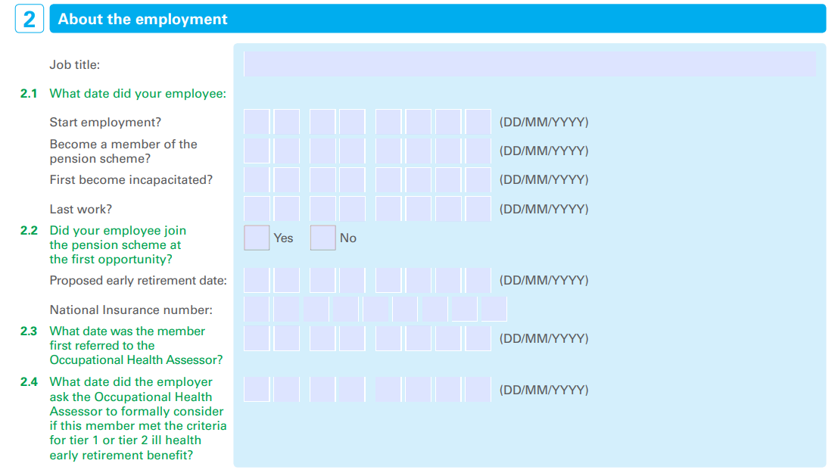
Employers must reply to the Administering Authority’s request for information as quickly as possible to ensure timely claims submission.
No further action should be required from the employer/employee for most claims of £500,000 (or less).

If the claim is over £500,000:
The Administering Authority will request the following information from the employer:
- Submission of the completed IHLI Claim Form with both Parts A and B fully completed by the employer and the employee, noting the employee’s consent requirement in Part B, sections 3 and 4.
Once the completed IHLI Claim Form has been received, the Administering Authority will submit this to Legal & General on the employer’s behalf.
  - Assessing a claim
If the claim is over £500,000, Legal & General will require additional information (as noted to be retained by the employer under 4.1) to check that the member met the ill health early retirement LGPS regulations. The insurer may request this information from the employer, the occupational health provider or the member’s doctor.
Upon receipt of the completed claim forms and, for claims over £500,000, all the relevant medical information/documents, Legal & General will assess the validity of the claim.
  - Paying a claim
Once a claim has been assessed as valid, the insurer will pay the claim amount directly to the Fund, as policyholder. The amount will then be added to the relevant employer’s pension fund assets to offset the pension strain costs which will also have been charged against the assets.
  - Additional information about claims
We would like to draw employers’ attention to the following points:
- Given the additional medical information/documents requirement for claims in excess of £500,000, employers may wish to consider adapting their current IHER processes to either:
inform their employee of the possible future requirement for the completion of the claim form at a later stage (if their retirement results in a strain cost over £500,000); or
get the employee to complete the relevant sections of the IHLI claim form in parallel with the referral to occupational health for assessment of ill health retirement.
Most claims are expected to be under £500,000.
- If an employer is required to submit additional medical information/documents, these can either be:
emailed via secure email to IHLI@hymans.co.uk. Prior to submitting any such claim documents, please send our IHLI team an email in the first instance and we will then reply with a link to our secure portal, Sharefile, for uploading the documents; or
posted directly to Legal & General at: Group Protection Benefits Team, Legal & General Assurance Society, Knox Court, 10 Fitzalan Place, Cardiff, CF24 0TL.
- Legal & General apply a 90-day notification period for submission of claims. This should have no impact on most claims as the Administering Authority will submit most claims on behalf of employers. However, for claims in excess of £500,000, it is ultimately each employer’s responsibility to engage with the claim process and ensure that the IHLI claim form is completed and submitted to the Fund within the 90-day notification period. Failure to submit a completed claim form may impact the claim assessment process and may result in the Administering Authority invoicing employers for a portion of the associated strain costs if the claim cannot be progressed with the insurer. This strain cost may need to be met via a one-off payment.
- IHLI does not cover strain costs relating to the ill health early retirement of former employees (i.e. deferred members of the Scheme) as these costs are typically far less than for current staff.
- Tier 3 ill health early retirements are not covered by the insurance. However, if a tier 3 member was to be upgraded to a tier 2 then this may be covered by the insurance. This would be on the proviso that both the original decision (to award the member a tier 3 IHER) and the decision to upgrade the member (to tier 2) occurred during the period when the insurance cover was in place.
- 4.1 explains that any active members who were already in the ill health early retirement medical assessment phase at 1st April 2021 would not be covered by the insurance. There are two key questions on the IHLI Claim Form which are relevant to this statement. These questions are set out below, along with explanations of what dates Legal & General would expect to be entered for each question.
Part A, 2.3: “What date was the member first referred to the Occupational Health Assessor?”
This is the date the member was first referred to occupational health to assess their condition for which they would subsequently be awarded ill health early retirement benefit.
Part A, 2.4: “What date did the employer ask the Occupational Health Assessor to formally consider if this member met the criteria for tier 1 or tier 2 ill health early retirement benefit?”
This is the date Legal & General would use to establish when the ill health early retirement process started. This date should be the first date you (the employer) first asked the occupational health team to review the member to consider if they would meet the criteria for tier 1 or tier 2 ill health early retirement.
- Employers should ensure that both their finance and HR teams are aware of the insurance and the claims process. This should ensure a streamlined process and timely claims submission and payment.
If you have any questions about the claims process, please get in touch with our IHLI team in the first instance. Our contact details are shown at the end of this document.

- Employee Assistance Programme
Legal & General offer a free Employee Assistance Programme to all employers who are covered by Ill Health Liability Insurance. This allows employees to call the Employee Assistance line at any time to talk through any problems that might be worrying them; from faulty goods bought, to matrimonial problems, tenancy issues or driving offences. Employers should have received copies of the insurer’s Employee Assistance Programme documentation (a flyer and brochure) as attachments to the email issued from our team.
  - Accessing the EAP service
Your employees can contact the service on 0800 197 0655. They may be asked to confirm the name of the Local Authority, County Council or Pension Fund they are in. The employee should quote ‘East Sussex’, ‘East Sussex County Council’ or ‘East Sussex Pension Fund’
Your employees can also access the service online by accessing the following link:
www.legalandgeneral.com/eap
The access code/username and password for website access is ‘worklifeeap’ in both cases and the employer code for the Health Risk Assessment tool on the website is also ‘worklifeeap’.
  - Who can access the EAP service?
The EAP service is open to all your employees, whether they are in the LGPS or not. Telephone support is also available to your employees’ immediate family.
Please feel free to circulate the EAP documents to your employees – though we would be grateful if you could ask your employees to only use the ‘Accessing the EAP service’ instructions above to ensure ease of access.
It is, of course, your (and your employees’) choice whether you/they take up the free EAP service offered by Legal & General. This document in no way constitutes advice from us to do so.

- Care Concierge
Legal & General have also launched a new Care Concierge service that can be accessed by all employers covered by Ill Health Liability Insurance. Care Concierge is a confidential telephone guidance service which allows employees to speak directly to a care expert about later life care needs for a loved one. Employers should have received copies of the insurer’s Care Concierge documentation (employer and employee brochures) as attachments to the email issued from our team.
  - Accessing the Care Concierge service
Your employees can access the Care Concierge service by calling Freephone 08000 608823 (Monday – Friday, 9am-5pm). As with the EAP service, callers may be asked to confirm the name of the Local Authority, County Council or Pension Fund they are in. The employee should quote ‘East Sussex’, ‘East Sussex County Council’ or ‘East Sussex Pension Fund’
Full details about the service can be found on Legal & General’s website, here. You can download brochures (separate employer and employee versions) using links at the bottom of the above webpage. Additionally, there are separate webpages for employees (here) and for the Later life care service (here).
  - Who can access the Care Concierge service?
All your employees (i.e. not just your LGPS employees) will automatically have access to the Guidance package level of the service for free. Benefits of this level of the service include:
- A 30-minute telephone consultation with a care expert.
- Support and an understanding of what type of care is needed, as well as how to arrange it.
- Guidance on typical care costs and the available options towards paying for care.
- An e-mail summarising everything discussed, tailored care guides, and a list of relevant services.
Employees can also access additional levels of support over and above the free Guidance package level. These additional levels are not free but are provided at discounted rates.
The Care Concierge documentation can also be circulated to your employees. Again, it is your (and your employees’) choice whether to take up the free Care Concierge service offered by Legal & General. This document in no way constitutes advice from us to do so.
- FAQs
  - How much will the insurance cost?
There will be no additional cash cost for Fund employers. The cost of the insurance will be met within your employer contribution rates set out in your Employer Valuation Results report*. For the avoidance of doubt, the insurance premium rate will not impact the certified employer contribution rates payable, so from 1st April 2021 all employers should ensure that they pay employer contributions to the Fund at their full certified rates. The insurance premium rate will be finalised prior to 1st April 2021, but it is expected to be lower than the premium rate currently being paid by insured employers within the Fund.
*This will represent a change in approach for employers who already have external insurance through Legal & General. Such employers will no longer receive invoices directly from the insurer (other than in respect of the current policy year to 31st March 2021).
Hymans Robertson LLP administer the insurance and are remunerated by Legal & General for their services on an introductory/administration fee basis – currently 10% of the annual premiums paid for IHLI.
  - Do employers need to supply membership data?
No. Employers do not need to submit membership data to the insurer. Data will be supplied by the Administering Authority on an annual basis on behalf of the insured employers. We would encourage employers to ensure that any data they provide to the Administering Authority continues to be as accurate as possible. The insurance premium and any potential claim payments will rely upon the underlying data provided to the insurer by the Administering Authority, which ultimately comes from employers in the first place.
  - Do employers need to inform the insurer of any new joiners or leavers throughout the year?
No. Joiners and leavers to the Scheme during the year will be captured by the insurer within the annual data submission from the Administering Authority. The insurer adopts a simplified accounting basis where membership movements over the year are assumed to have occurred midway through the year. This avoids the need for employers to notify the insurer about any changes in employees and/or working hours.
  - How will employers who join or leave the Fund during the year be treated?
New employers who join the Fund during the year will either be automatically enrolled into the policy from their date of joining the Fund (if they have less than 200 active members) or will be given the option to opt in to the cover (if they have more than 200 members). Conversely, any employer who leaves the Fund during the year will automatically cease to be covered from their date of exiting the Fund.

- Employers who previously had individual employer held policies
  - Transitioning cover
Any employers in East Sussex Pension Fund who previously had individual employer held IHLI policies will have their individual policies terminated from midnight on 31st March 2021, with their cover being transferred across to the new, Fund held policy from 1st April 2021. This will ensure continuous cover for those employers. For the avoidance of doubt, the cover offered by the new Fund held policy is identical to the cover under previous individual employer held policies.
Employers who currently have individual IHLI policies will not be required to supply 2021 renewal data. All such employers will receive an email in due course which will set out any credits/debits due in respect of the period to 31st March 2021.
Any ongoing claims for currently insured employers will continue to follow the usual claim process. If the member in question has a date of retirement prior to 1st April 2021 then the claim payment will be made to the individual employer. If the date of retirement is on or after 1st April 2021 then the claim payment will be made to the Fund.
  - Contribution rates
Employers who previously had the insurance via an individual policy may have been permitted to receive a reduction in their employer contribution rate payable to the Fund. This reduction will no longer apply from 1st April 2021 as the premium for the Fund held policy will be paid by the Fund and not the employer. All employers should pay employer contributions to the Fund at their full certified rate from 1st April 2021.
  - Claim forms and payments
Going forward, claim payments will be made directly to East Sussex Pension Fund instead of being paid to individual employers (as would have been the case under individual employer held policies). Consequently, employers should no longer provide financial claim forms when submitting claims.

- Hymans’ IHLI team contact details
Any queries should be directed to our IHLI team in the first instance. We can be reached at:
Email: IHLI@hymans.co.uk
Telephone: 0121 210 4356
Address: IHLI Team, Hymans Robertson LLP, 45 Church Street, Birmingham, B3 2RT.

Prepared by:

IHLI Team
March 2021
For and on behalf of Hymans Robertson LLP

Hymans Robertson LLP (“Firm”, “we”, “us” and “our”) is an ancillary insurance intermediary in relation to the Services provided to insured policyholders under their IHLI Agreements and we are authorised and regulated by the Financial Conduct Authority (Financial Services Register number 414430). Please refer to the following link for further details: The Firm is remunerated for carrying out promotional and administration services on behalf of Legal & General Assurance Society Limited (“Legal & General”).

